Assignment 6.2:

* Fetch date and temperature from temperature_data where zip code is greater than

300000 and less than 399999.

Select date, temperature from temperature_data where zipcode>300000 and zipcode<399999;

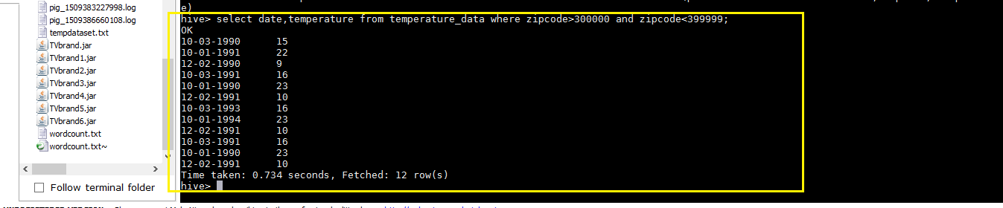

* Calculate maximum temperature corresponding to every year from temperature_data

table.

select substring(date,7,10) as year, max(temperature) as max_temperature from temparature_data group by substring(date,7,10);

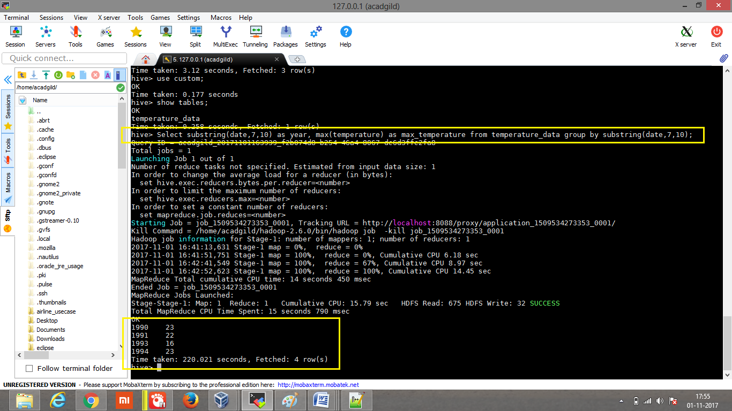

* Calculate maximum temperature from temperature_data table corresponding to those

years which have at least 2 entries in the table.

Select substring(date,7,10), max(temperature) from temperature_data group by substring(date,7,10) having count(date) > 1;

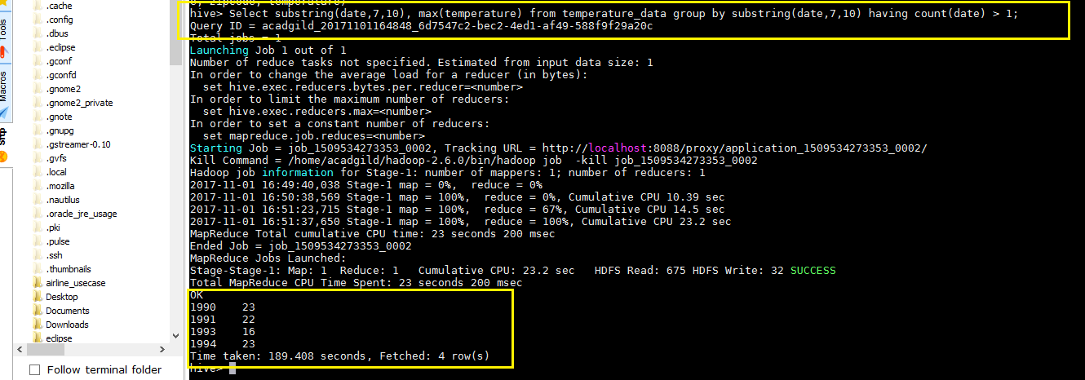

* Create a view on the top of last query, name it temperature_data_vw.

Create view if not exists temperature_data_vw as Select substring(date,7,10), max(temperature) from temperature_data group by substring(date,7,10) having count(date) > 1;

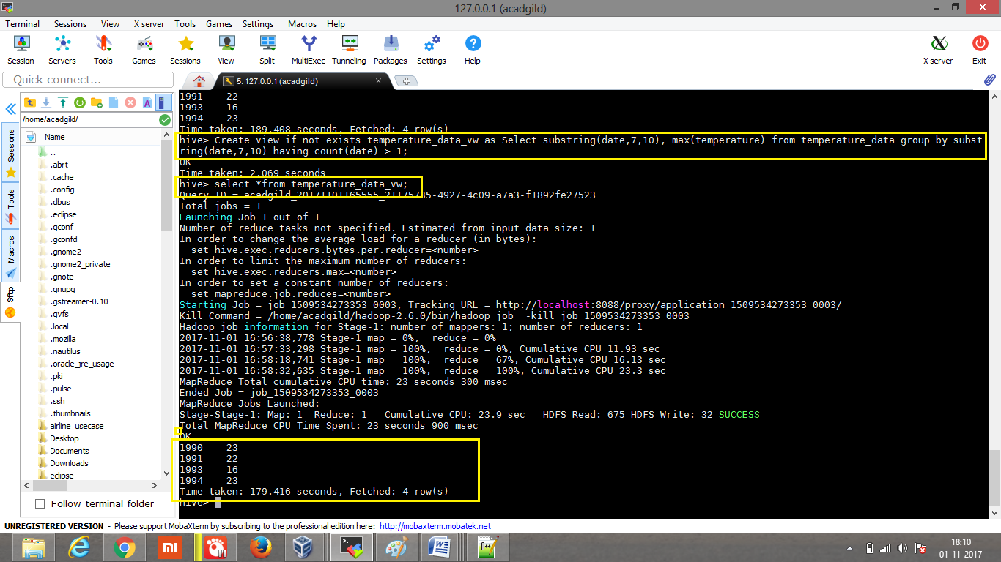

* Export contents from temperature_data_vw to a file in local file system, such that each

file is '|' delimited.

Insert overwrite local directory ‘/home/acadgild/manjunath’ row format delimited fields terminated by ‘|’ select * from temperature_data_vw;

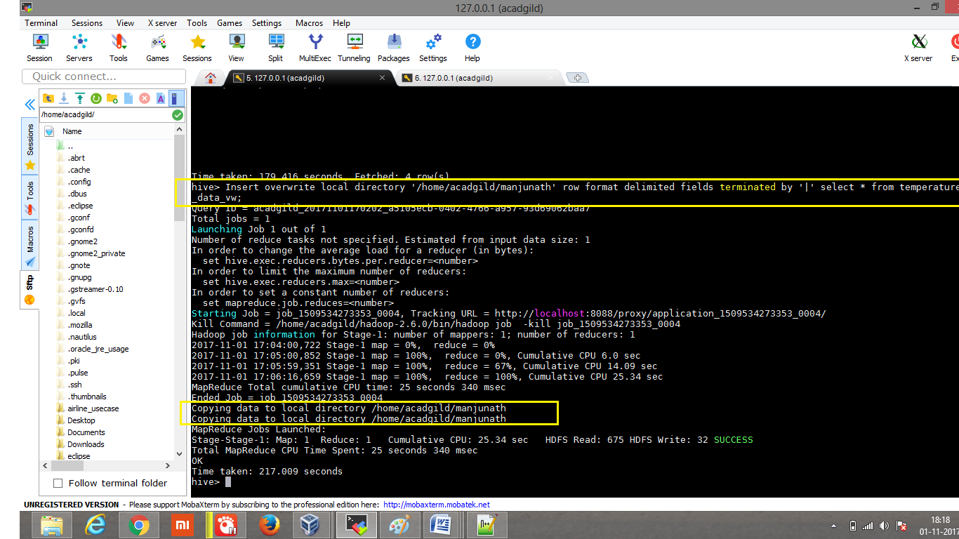

Copied data in the directory manjunath.

